Luigi Pericle (1916-2001) _ Beyond the visible
Fondazione Querini Stampalia. Area Carlo Scarpa
S. Maria Formosa, Castello 5252, Venezia

11 May > 24 November 2019
Press Preview 8/9/10 May 2019 10:00am – 6:00pm

The Fondazione Querini Stampalia of Venice hosts the first retrospective exhibition of the artist Luigi Pericle (Basel 1916-Ascona 2001), a leading figure of the European painting scenario in the second half of the 20th century, rescued after years of oblivion.
Born in Basel, but of Italian origins (in fact, his father was from the Marche region, precisely from Monterubbiano), Luigi Pericle has lived and enlivened a chapter of the history of art acclaimed by the most renowned names of the artistic panorama: from collector Peter G. Staechelin to the trustee of the Tate Gallery. Sir Herbert Read, the museologist and curator of the York Art Gallery, Hans Hess, and the owners of the Arthur Tooth&Sons art gallery in London, where his works were exhibited along with Appel, Jorn, Tàpies, Dubuffet, and Mathieu. Following an important itinerant solo exhibition through several British museums, Pericle suddenly retreated to a secluded life. The year was 1965. Together with his wife Orsolina Klainguti, in the 1950’s he had moved to the ‘anarchic paradise’ of Monte Verità, the famous ‘Hill of Utopia’ tucked amidst the woods of Canton Ticino overlooking Ascona, facing the northern point of Lake Maggiore. Here, he continued to work, study, and reflect in solitude.

Rescued from oblivion, today Luigi Pericle is the focus of an extensive project aimed at a critical and philological recovery of his work. The project of study, restoration, conservation, and cataloguing of his artistic heritage, secured by the “Archivio Luigi Pericle” Association, sees the first step of a thorough path aimed at enhancing his production in the Venetian exhibition in the context of the six months of the Biennale. A scientific catalogue published by Silvana Editoriale will lead viewers along an exhibit of 50 works, including paintings on canvas and masonite, India ink drawings on paper from the Sixties and Seventies; the fruit of a tireless investigation into the language of signs and painting meant as an utterance of intimate drives and of a visionary exploration through the deepest folds of our consciousness.
The large counter designed by famous architect Carlo Scarpa – who restored the exhibition area on the ground floor of the Fondazione – will gather unpublished testimonies, notes, autographed comments, exercises of analysis and pages of a diary, together with other graphic works that will unveil the multifaceted personality of Pericle as a man, an artist, a thinker.
As a painter, an illustrator, and all around scholar, Luigi Pericle, was influenced by theosophy and esoteric doctrines, and took part in the cultural debate engendered over the past century by these trends. Pericle breathed in the mystic air of Monte Verità (literally “Mountain of Truth”), which, in the early 19th century, welcomed the community founded by Ida Hofmann and Heinrich Oedenkoven on the Hill of Utopia that attracted exponents from the European ‘counter-culture’ of the time. Beginning in the 1930’s, these same places saw the beginning of the intellectual adventure of the Eranos meetings, promoted by Carl Gustav Jung (whose The Red Book was rediscovered in recent years and exhibited at the Venice Biennale in 2013) and by Dutch theosophist and painter Olga Froebe-Kapteyn.

Pericle was a multifaceted artist with manifold interests; he escaped any classification and confirmed to be a professional painter as well as a talented cartoonist. In 1951, he created the marmot Max, protagonist of the homonymous comic strips with no texts, which soon became a famous character in Europe and farther afield, in the US and Japan. With his work as an illustrator, Pericle gained international fame, and his comics were released by New York publisher Macmillan in popular newspapers such as The Washington Post, The Herald Tribune, or the magazine Punch. Concurrently with this ‘pop’ activity, his second life as a painter engaged in informal abstract art saw him conjecture obsessively on peculiar processing techniques, on experimentation with materials, on a daily exploration aimed at bending the language of painting to the needs of the soul in search of forms, gestures, symbols, scenarios, creatures, openings and parallel universes that could be the reification of the invisible and of a truth existing beyond contingence.

The volumes of literature, philosophy, Egyptian art, theosophy, astrology that crowded his library served to quench Pericle’s versatile thirst for knowledge, the miraculous source of an inspiration that was not confined to painting but, rather, entrusted to thousands of documents that unveil a plethora of horoscopes, ufology essays, notebooks rich with quotes and Japanese ideograms, cosmic symbols, Chinese medicine and homeopathic recipes. “Art”, quoting Pericle, “reflects man’s spiritual inclination and is like an instrument endowed with clairvoyance; art always has the presentment of future events.” His imagery was thus enlivened with hypnotic figures, visionary scenarios, alien worlds, stargates open toward mechanic civilizations. A magnificent obsession that led him far from ‘painting as mere painting’ and turned him into a free thinker and even the author of a science fiction novel set in a post-atomic world. This unpublished work has emerged today along with paintings devoted to diverse themes that are presented in this exhibit according to a chronological path covering two decades and divided by series: pyramids and clocks (March of Time), stargates (Matri Dei), moons, golems, archangels, monsters (Wood Demon or Der Hütter Der Schwelle), which are reminiscent of Francisco Goya’s “sleep of reason” that here ignites new possibilities of investigating the unknown.

The exhibition promoted by the Ascona “Archivio Luigi Pericle” Association aims at shedding light on an extraordinarily valuable author who belongs to that category of artists – names come to mind such as Hilma af Klint, whose work was presented at the Venice Biennale in 2013 – who preferred to let their work speak only after their death, nevertheless impressing it with an energy that would deserve posthumous rediscovery. After the death of Luigi Pericle, who died without heirs in 2001, his home in Ascona remained closed for fifteen years until 2016, when it was purchased by new owners who showed a profound sensitivity to the fascination of its glorious past. This house has revealed an immense heritage of works and writings that remained buried for years; a summa of the universal thought catalogued by Pericle with monastic rigor and that remained crystallized intact until today.
The exhibition is curated by art critic and historian Chiara Gatti with the collaboration of Marco Pasi from the University of Amsterdam (UvA) and the European Association for the Study of Religions (EASR), Michele Tavola from the Galleries of Venice Academy and Luca Bochicchio, director of the Jorn Home Museum of Albisola, AdAC University of Genoa.
The project is run under the auspices of, among others, Swiss Confederation Consulate General of Switzerland in Milan, Council of State of the Republic and Canton of Ticino, Ticino Tourism, Monte Verità Foundation of Ascona, Eranos Foundation of Ascona, Cà Foscari University of Venice and with the support of the Swiss Arts Council Pro Helvetia. The catalogue is published by Silvana Editoriale publishers.

“There is no time for spirituality in art.
It escapes human transience; it is never old and never new.
It is, because it is essential; or rather, it is the essential way to express Truth.
The essential is not what comes from the artist, but through the artist”.
Luigi Pericle

Technical card

Luigi Pericle (1916-2001)_Beyond the visible
Fondazione Querini Stampalia, Area Carlo Scarpa
S. Maria Formosa, Castello 5252 - Venezia
manifestazioni@querinistampalia.org
www.querinistampalia.org
tel. +39-041/2711411

Open to the public: 11 May > 24 November 2019
Press Preview: 8/9/10 May 2019 10:00am-6:00pm

PRESS IMAGES
For high-resolution images, please contact the “Archivio Luigi Pericle”

Archivio Luigi Pericle, Ascona, Switzerland
Andrea & Greta Biasca-Caroni
tel. +41 (0)79 245 09 65 - +41 (0)79 621 23 43
c/o Hotel Ascona – Via Signore in Croce, 1 – CH – 6612 Ascona
www.luigipericle.org - info@luigipericle.org

Main Partners
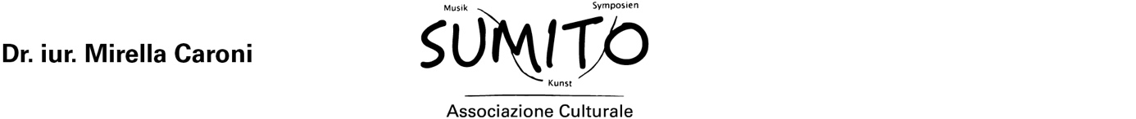

Institutional Partners

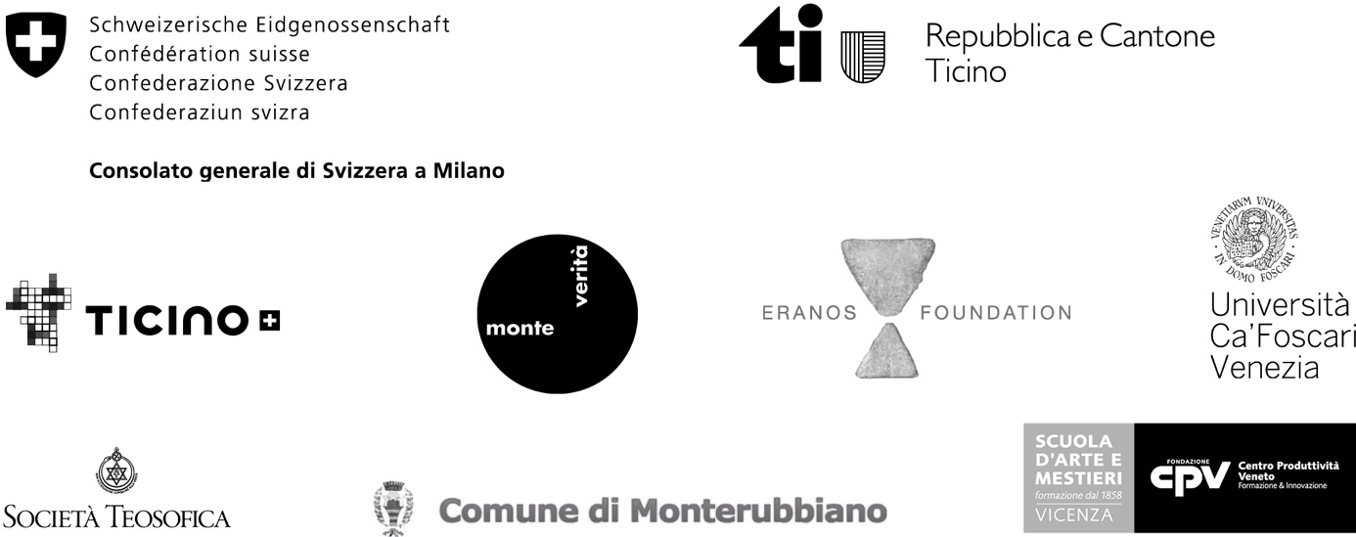

With the support of

